ACM-4000 imaging process.

If your ACM-4000 display looks like this on an HMI / TV, the system will need to be imaged.

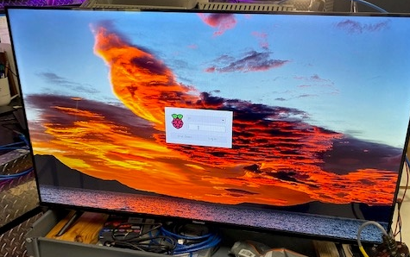

You will need two programs

1. RPIboot
2. Rapspberry Pi imager

Connect USB C cable from PC to USB OTG connector on ACM-400 with power off @ ACM-4000

With a jumper wire, jumper the two pins together that are circled in the picture below.

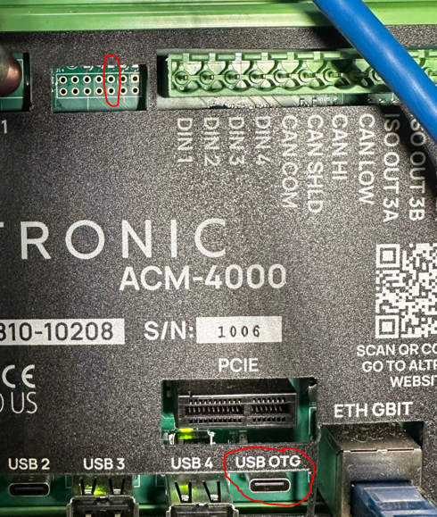

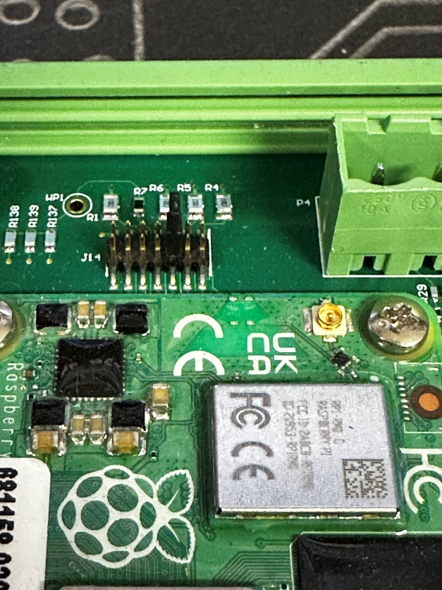

On newer boards, jump out the third set of pins counting from right to left.

Power up the ACM-4000, and open the RPIboot software. You will see RPIboot program loading items and disappear, the ACM 4000 will now look like two USB thumb drives on your PC. Windows may ask you to format your thumb drive; ignore this. You can remove the jumper wire at this time.

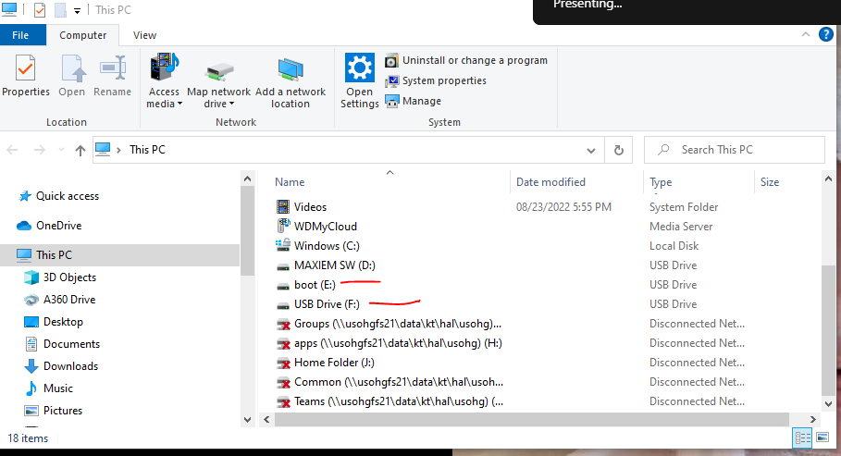

Open the Raspberry Pi Operating system button and select

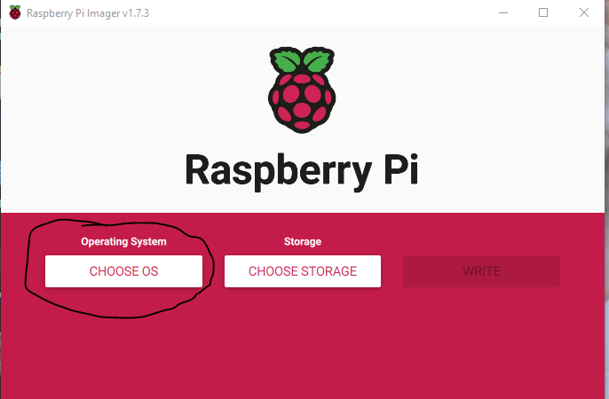

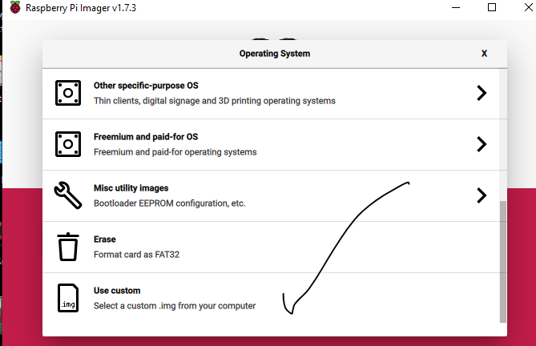

Navigate to the file you want to use.

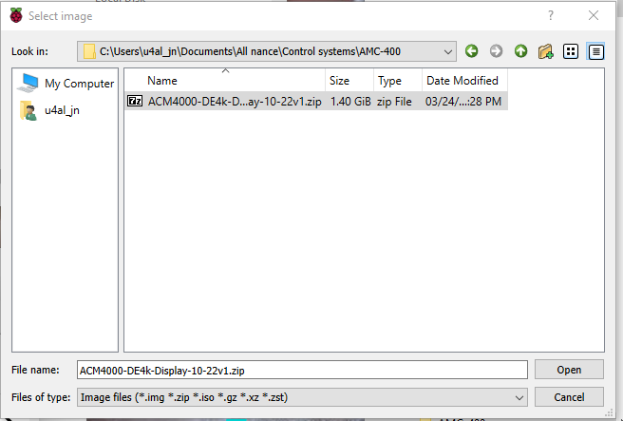

And select open

Now chose storage

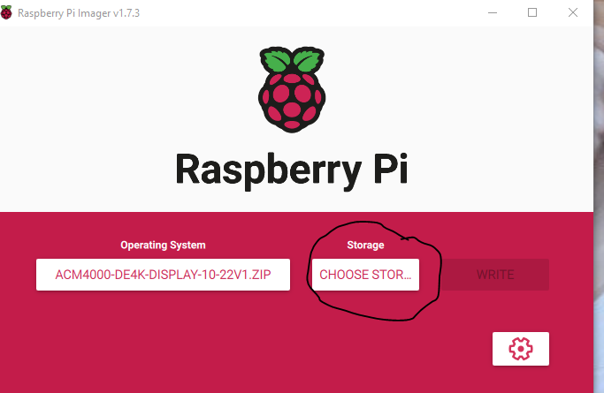

And select

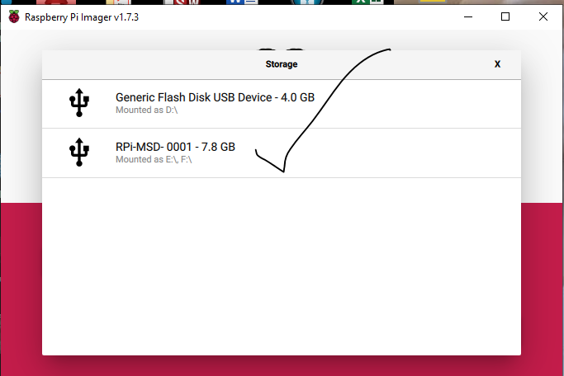

Now click the write button, Wait about 45 minutes.

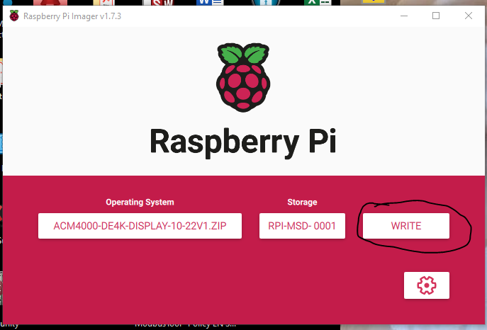

Click yes

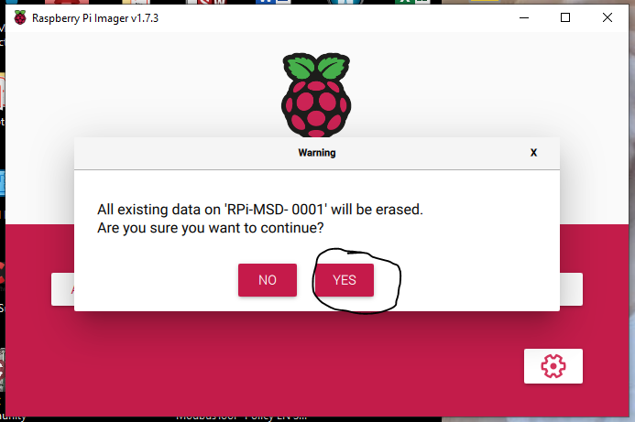

System will Write and then verify. Once complete, the system will tell you to remove the hardware. At this point power down the ACM-4000 and disconnect from you PC and remove the programing connector.

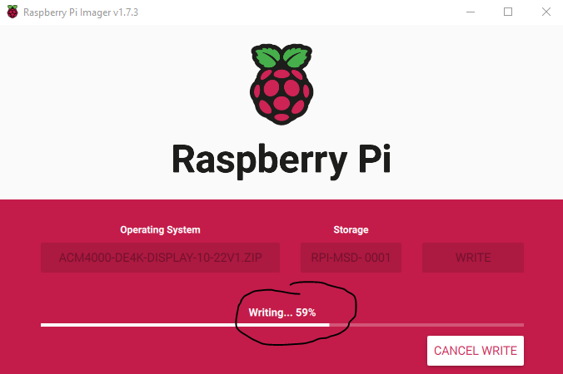

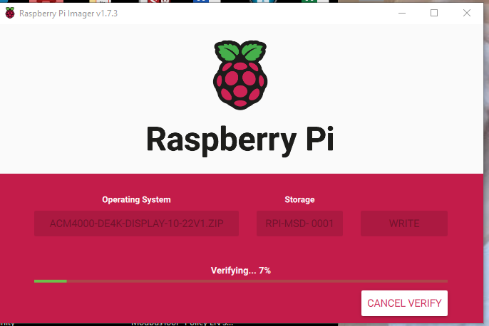

If you get pop-ups that look like this,,, ignore them.

. 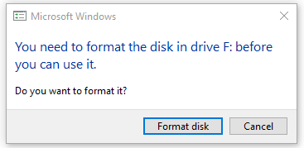

When you see this, your done. Close the software, power off the ACM-4000, remove the programming jumper tool, and disconnect the USB C cable. Then power the system back on.

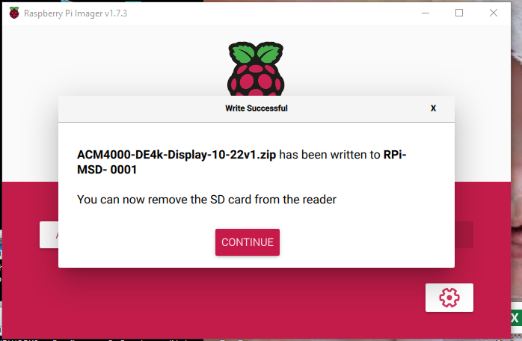

When viewing on the large monitor, you can toggle from web browser mode to Kiosk mode by holding ALT and F4. Some key boards will require you to hold the FN button too. This is with a wireless keyboard connected to USB port #4 on the ACM-4000